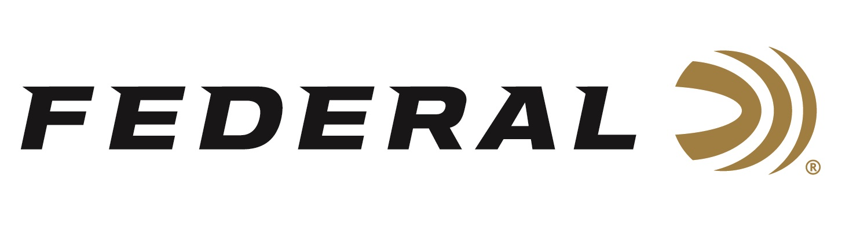

FOR IMMEDIATE RELEASE

Writing for an Icon on “It’s Federal Season” Podcast

ANOKA, Minnesota – January 18, 2022 – Jeremy Stafford has been serving residents of Los Angeles for decades in several roles with the Los Angeles Police Department, had a 13-year distinguished career as a Marine, but for this highly driven professional, he wanted to share his firearms expertise on a broader scale. A break came his way and now, besides his job in law enforcement, he’s added the title of Handgun Editor for an industry icon, Guns & Ammo magazine to his impressive resume. Stafford sits down with Federal and records a great conversation on getting his start in the outdoor writer business.

“Few have the experience that Jeremy Stafford brings to the position of Handgun Editor for one of the great gun magazines,” states Jason Nash, Federal Ammunition’s Vice President of Marketing. “We were honored to have Jeremy into our offices to test our revolutionary new 30 Super Carry personal defense ammunition and get his take on the product introduction,” states Nash. In this in-depth discussion, Stafford walks the audience through his beginnings in the industry and gives his honest review of the new 30 Super Carry from Federal.

Episode #29 “Writing for an Icon”
https://www.federalpremium.com/this-is-federal/podcast/

Stafford is the feature writer on the new 30 Super Carry product release on the cover of the March issue of Guns & Ammo magazine. Look for that coverage at your favorite newsstand location or at www.gunsandammo.com.

In addition to the review of the new cartridge, Federal’s handgun product line manager Chris Laack walks through the evolution of 30 Super Carry and outlines the features and benefits of the revolutionary personal defense product.

For this episode, besides listening on the Federal Premium website or Talk North podcast network, you can also subscribe to Federal Ammunition’s YouTube channel (https://www.youtube.com/user/federalpremiumammo) and tune in for the discussion.

Federal Ammunition can be found at dealers nationwide or purchased online direct from Federal. For more information on all products from Federal or to shop online, visit www.federalpremium.com.

Press Release Contact: JJ Reich
Senior Manager – Press Relations
E-mail: VistaPressroom@VistaOutdoor.com

About Federal Ammunition
Federal, headquartered in Anoka, MN, is a brand of Vista Outdoor Inc., an outdoor sports and recreation company. From humble beginnings nestled among the lakes and woods of Minnesota, Federal Ammunition has evolved into one of the world's largest producers of sporting ammunition. Beginning in 1922, founding president, Charles L. Horn, paved the way for our success. Today, Federal carries on Horn's vision for quality products and service with the next generation of outdoorsmen and women. We maintain our position as experts in the science of ammunition production. Every day we manufacture products to enhance our customers' shooting experience while partnering with the conservation organizations that protect and support our outdoor heritage. We offer thousands of options in our Federal Premium and Federal® lines-it's what makes us the most complete ammunition company in the business and provides our customers with a choice no matter their pursuit.

